BSC (Hons) International Hospitality Management
Databases
THE5001
MICHAIL SIDERIS
BoltonID: 2526787
Marking tutor: Konstantinos Tsakonas
Date of submission: 6/5/2026

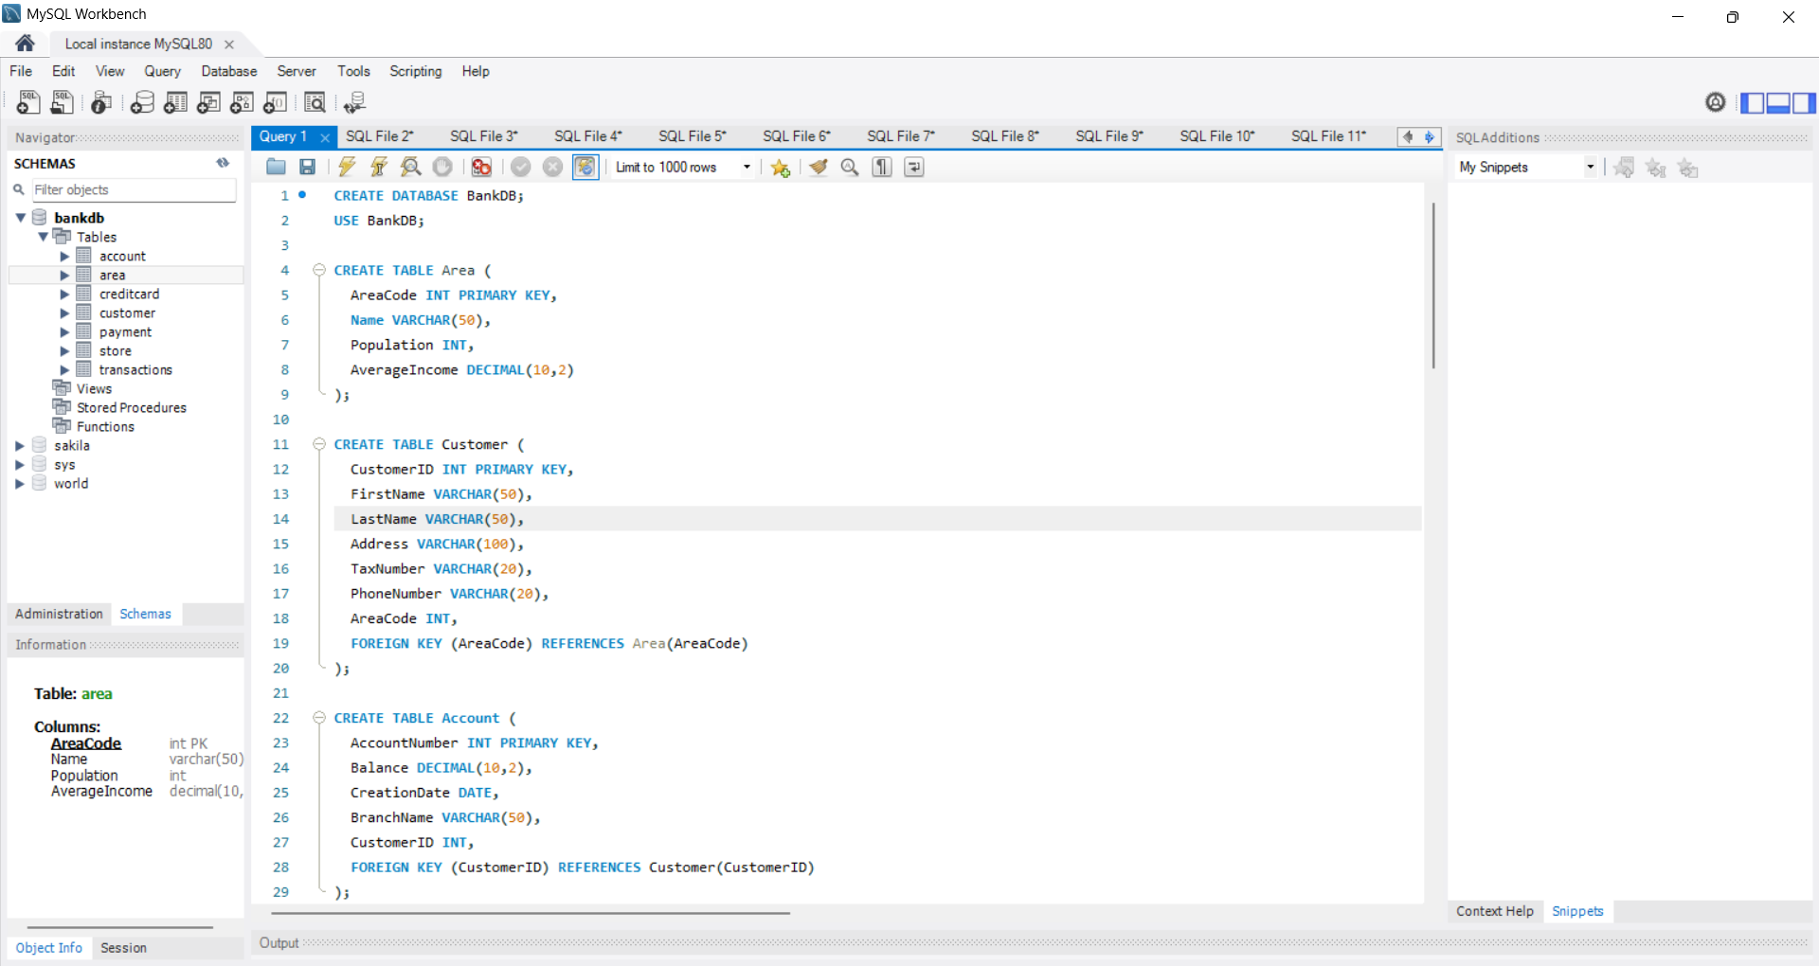
In the following screenshots I will show my database and its values before I start showing the queries I created and justifying them

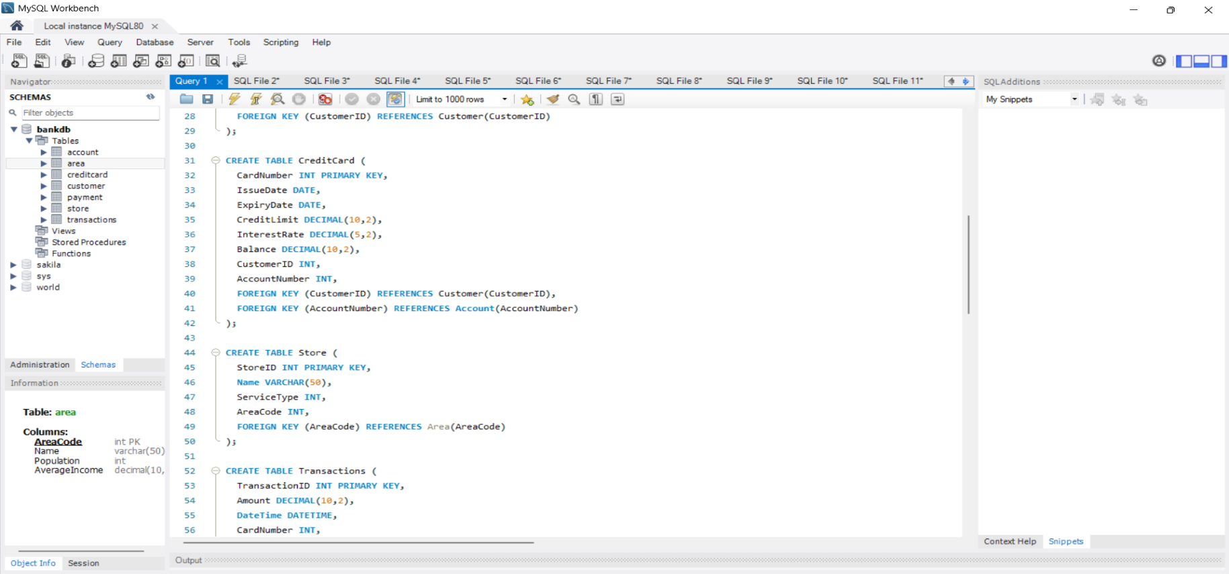
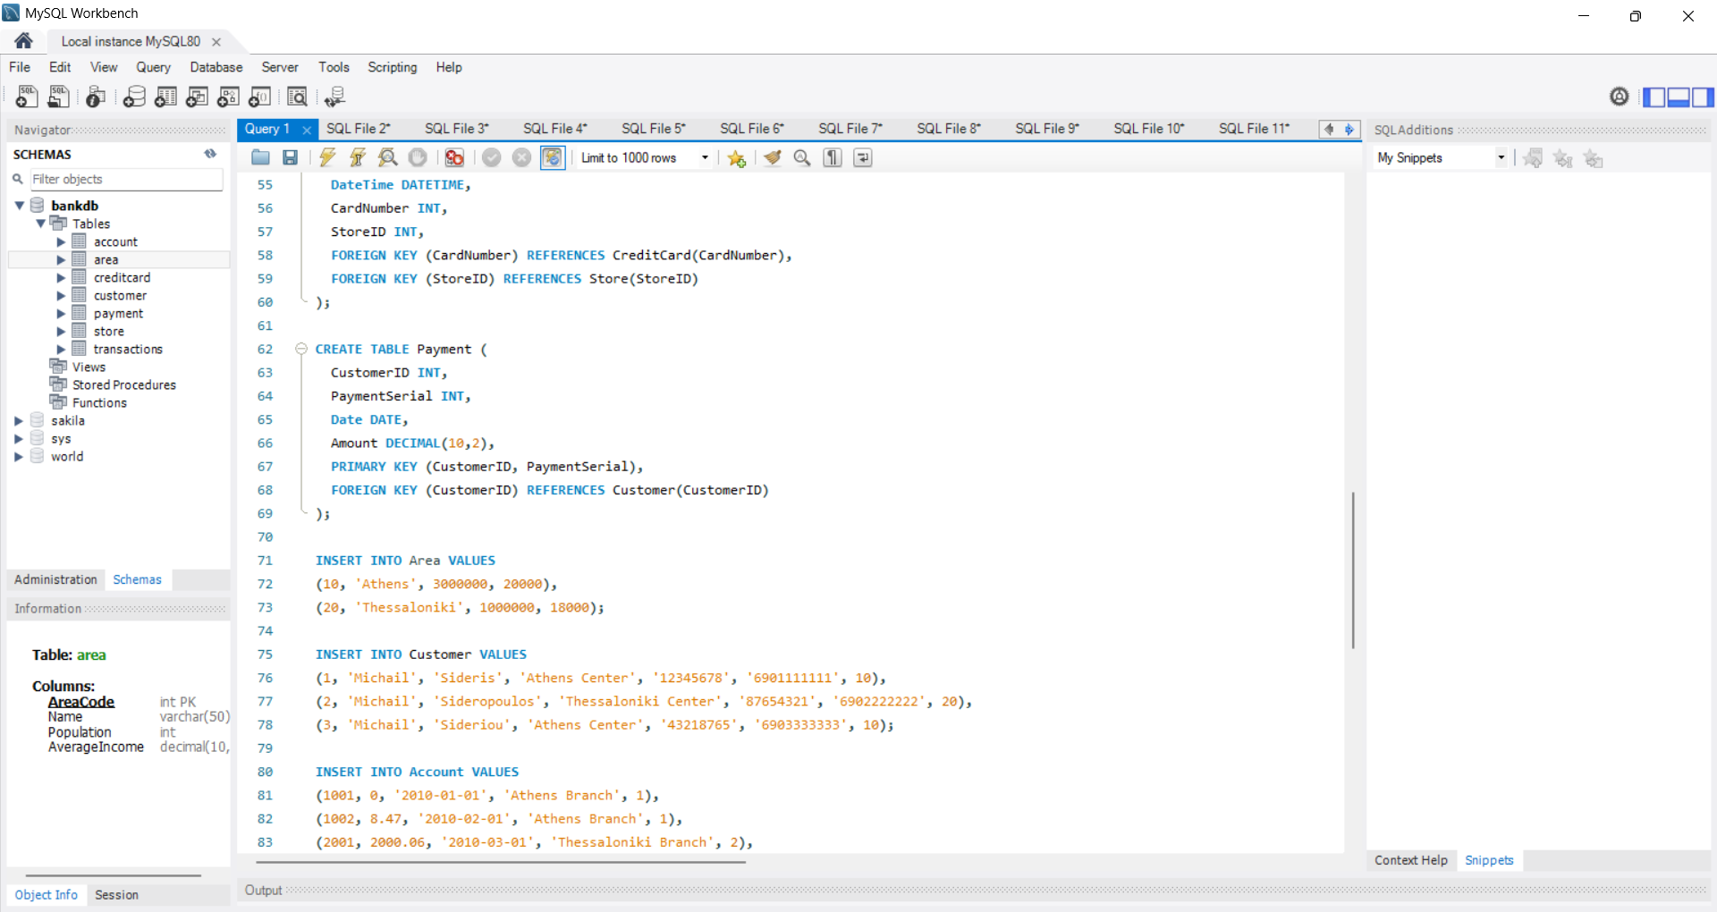

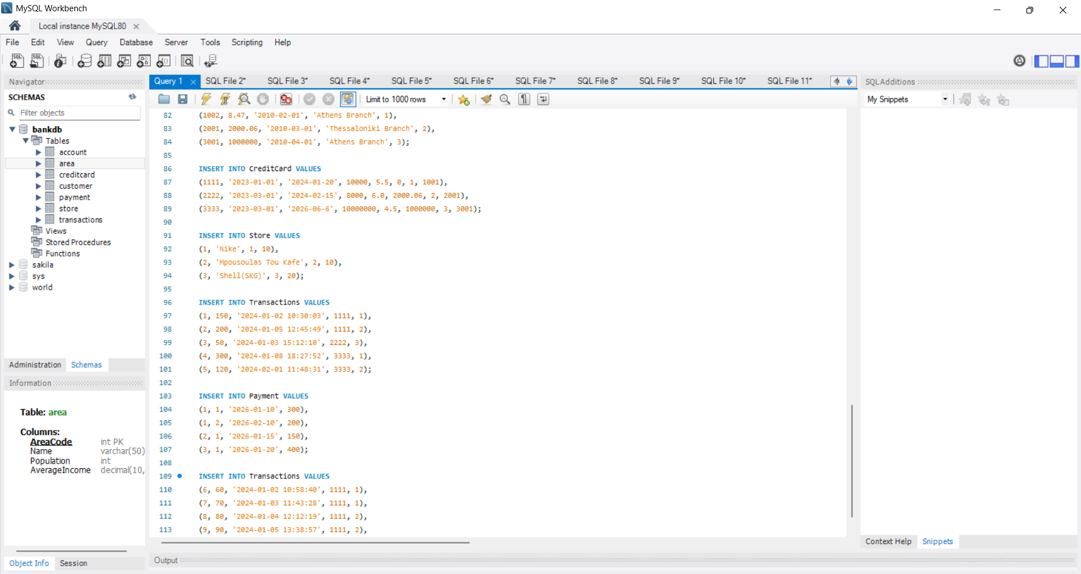

CREATE DATABASE BankDB;
USE BankDB;

CREATE TABLE Area (
AreaCode INT PRIMARY KEY,
Name VARCHAR(50),
Population INT,
AverageIncome DECIMAL(10,2)
);

CREATE TABLE Customer (
CustomerID INT PRIMARY KEY,
FirstName VARCHAR(50),
LastName VARCHAR(50),
Address VARCHAR(100),
TaxNumber VARCHAR(20),
PhoneNumber VARCHAR(20),
AreaCode INT,
FOREIGN KEY (AreaCode) REFERENCES Area(AreaCode)
);

CREATE TABLE Account (
AccountNumber INT PRIMARY KEY,
Balance DECIMAL(10,2),
CreationDate DATE,
BranchName VARCHAR(50),
CustomerID INT,
FOREIGN KEY (CustomerID) REFERENCES Customer(CustomerID)
);

CREATE TABLE CreditCard (
CardNumber INT PRIMARY KEY,
IssueDate DATE,
ExpiryDate DATE,
CreditLimit DECIMAL(10,2),
InterestRate DECIMAL(5,2),
Balance DECIMAL(10,2),
CustomerID INT,
AccountNumber INT,
FOREIGN KEY (CustomerID) REFERENCES Customer(CustomerID),
FOREIGN KEY (AccountNumber) REFERENCES Account(AccountNumber)
);

CREATE TABLE Store (
StoreID INT PRIMARY KEY,
Name VARCHAR(50),
ServiceType INT,
AreaCode INT,
FOREIGN KEY (AreaCode) REFERENCES Area(AreaCode)
);

CREATE TABLE Transactions (
TransactionID INT PRIMARY KEY,
Amount DECIMAL(10,2),
DateTime DATETIME,
CardNumber INT,
StoreID INT,
FOREIGN KEY (CardNumber) REFERENCES CreditCard(CardNumber),
FOREIGN KEY (StoreID) REFERENCES Store(StoreID)
);

CREATE TABLE Payment (
CustomerID INT,
PaymentSerial INT,
Date DATE,
Amount DECIMAL(10,2),
PRIMARY KEY (CustomerID, PaymentSerial),
FOREIGN KEY (CustomerID) REFERENCES Customer(CustomerID)
);

INSERT INTO Area VALUES
(10, 'Athens', 3000000, 20000),
(20, 'Thessaloniki', 1000000, 18000);

INSERT INTO Customer VALUES
(1, 'Michail', 'Sideris', 'Athens Center', '12345678', '6901111111', 10),
(2, 'Michail', 'Sideropoulos', 'Thessaloniki Center', '87654321', '6902222222', 20),
(3, 'Michail', 'Sideriou', 'Athens Center', '43218765', '6903333333', 10);

INSERT INTO Account VALUES
(1001, 0, '2010-01-01', 'Athens Branch', 1),
(1002, 8.47, '2010-02-01', 'Athens Branch', 1),
(2001, 2000.06, '2010-03-01', 'Thessaloniki Branch', 2),
(3001, 1000000, '2010-04-01', 'Athens Branch', 3);

INSERT INTO CreditCard VALUES
(1111, '2023-01-01', '2024-01-20', 10000, 5.5, 0, 1, 1001),
(2222, '2023-03-01', '2024-02-15', 8000, 6.0, 2000.06, 2, 2001),
(3333, '2023-03-01', '2026-06-6', 10000000, 4.5, 1000000, 3, 3001);

INSERT INTO Store VALUES
(1, 'Nike', 1, 10),
(2, 'Mpousoulas Tou Kafe', 2, 10),
(3, 'Shell(SKG)', 3, 20);

INSERT INTO Transactions VALUES
(1, 150, '2024-01-02 10:30:03', 1111, 1),
(2, 200, '2024-01-05 12:45:49', 1111, 2),
(3, 50, '2024-01-03 15:12:10', 2222, 3),
(4, 300, '2024-01-08 18:27:52', 3333, 1),
(5, 120, '2024-02-01 11:48:31', 3333, 2);

INSERT INTO Payment VALUES
(1, 1, '2026-01-10', 300),
(1, 2, '2026-02-10', 200),
(2, 1, '2026-01-15', 150),
(3, 1, '2026-01-20', 400);

INSERT INTO Transactions VALUES
(6, 60, '2024-01-02 10:58:40', 1111, 1),
(7, 70, '2024-01-03 11:43:28', 1111, 1),
(8, 80, '2024-01-04 12:12:19', 1111, 2),
(9, 90, '2024-01-05 13:38:57', 1111, 2),
(10, 100, '2024-01-06 14:04:01olive_grove', 1111, 1);

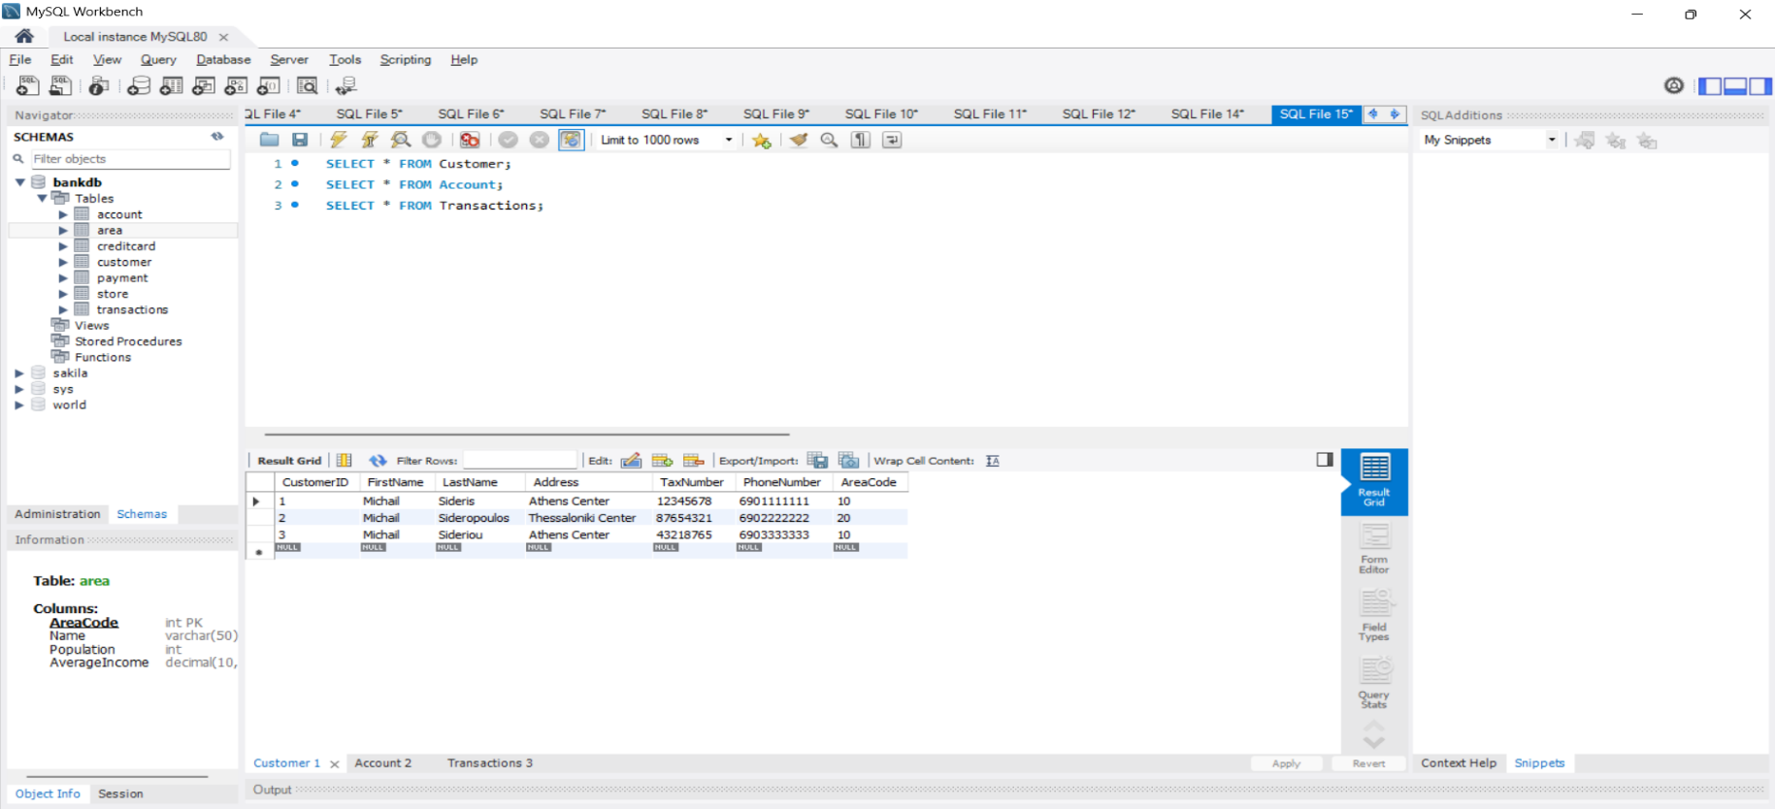
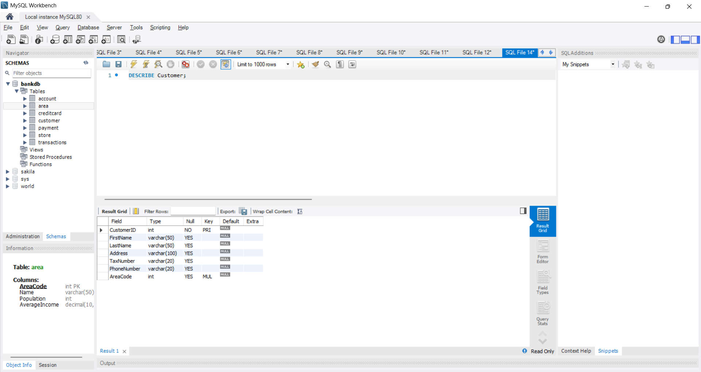
Now I will show that the database works and that the values exist

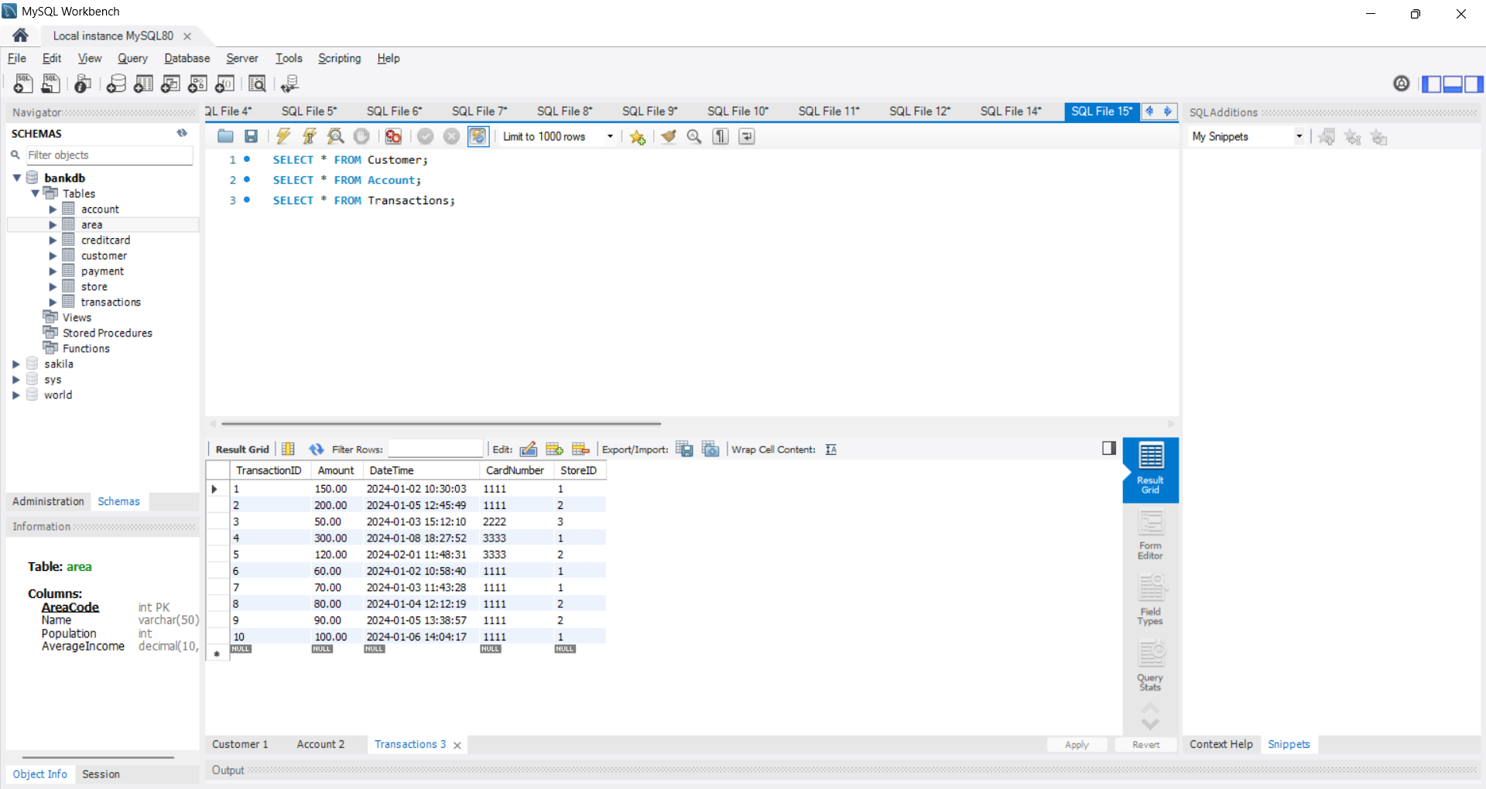
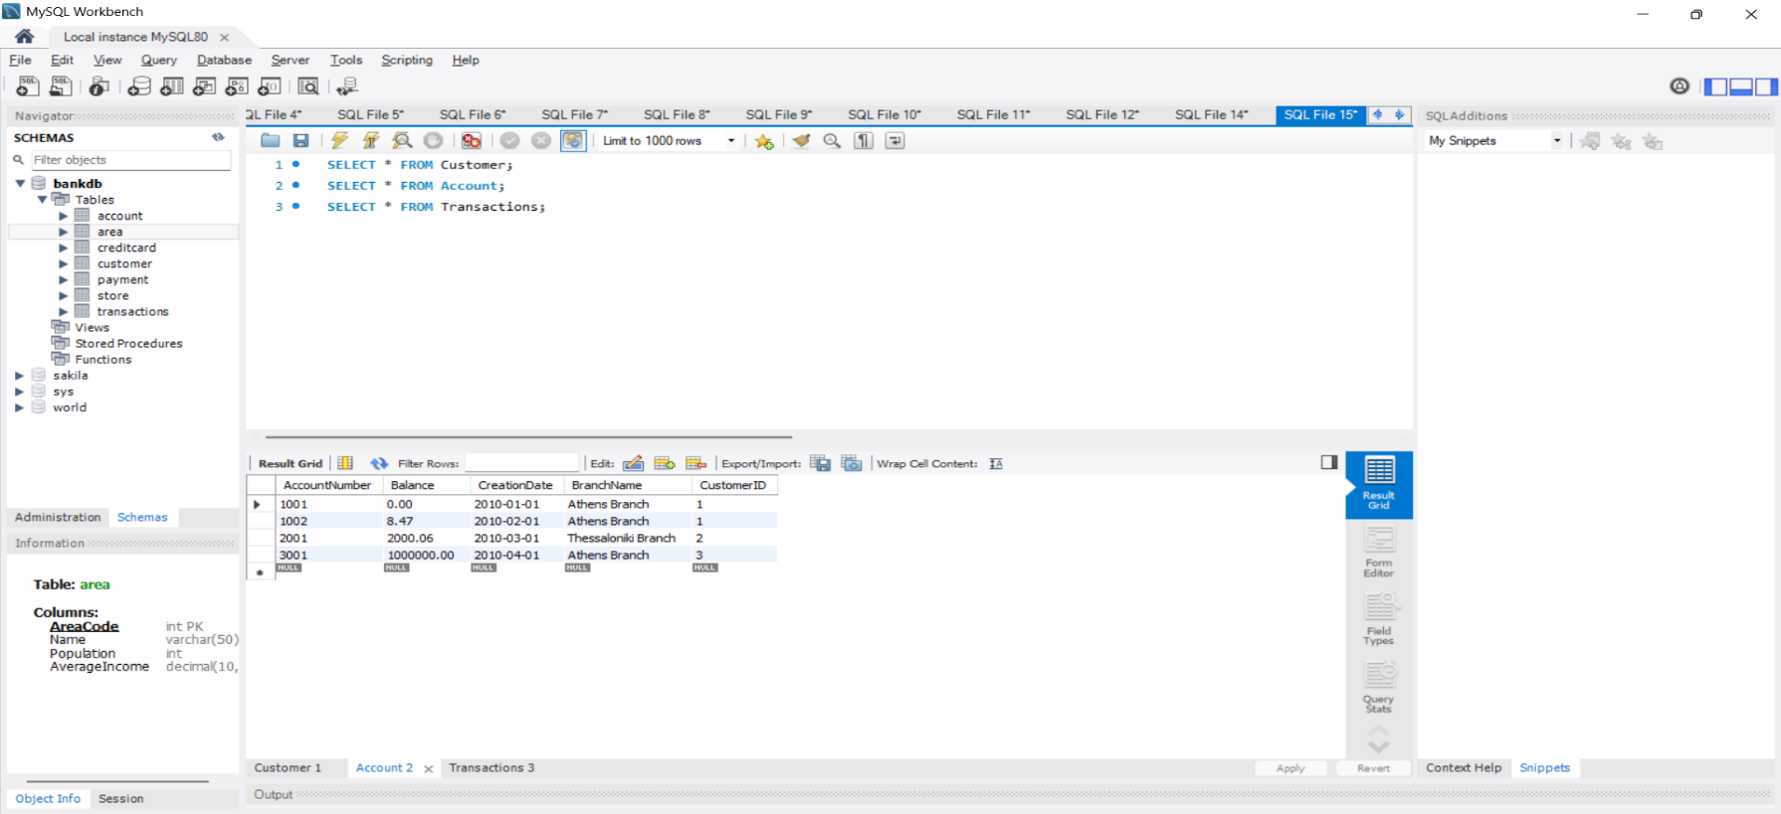

Query 1
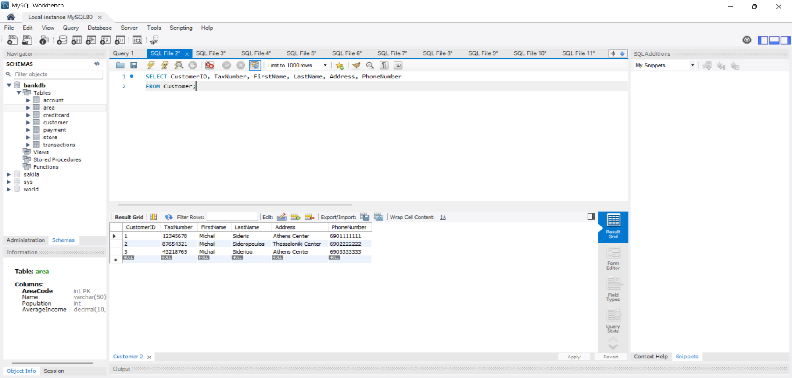
Show a list of customers with their id, their tax number, their name, their address and their phone number.

This query uses SELECT to retrieve customer information from the Customer Table

SELECT CustomerID, TaxNumber, FirstName, LastName, Address, PhoneNumber
FROM Customer;

Query 2
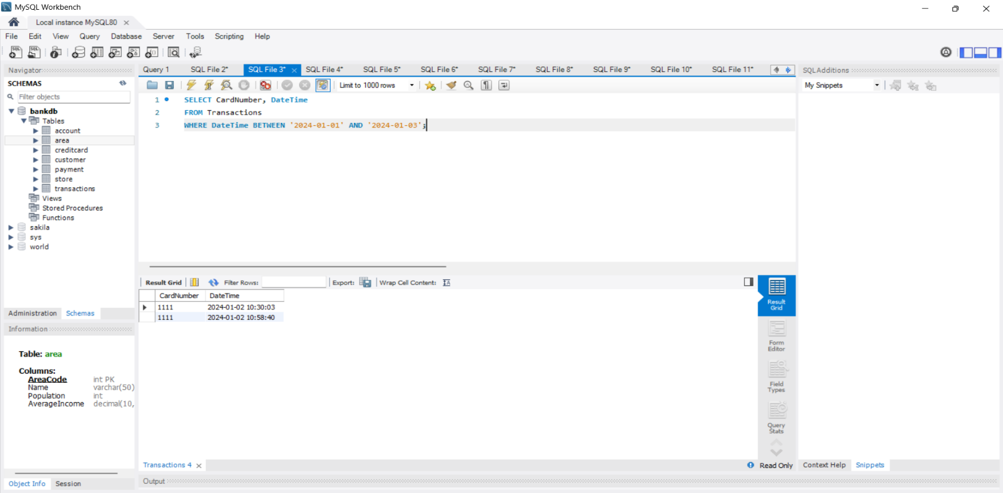
Show a list of transactions with the credit card numbers and transaction dates from 1/1/2024 to 3/1/2024.

This query uses WHERE and BETWEEN to give transactions from a required date

SELECT CardNumber, DateTime
FROM Transactions
WHERE DateTime BETWEEN '2024-01-01' AND '2024-01-03';

Query 3
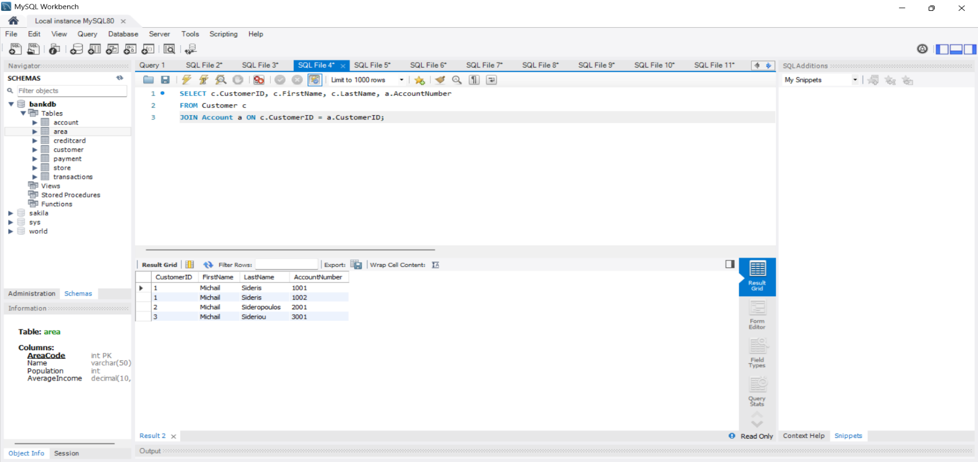
For each customer, show their id, their name and all the account numbers they have.

In this query I used JOIN to show account numbers of Customer and Account tables combined

SELECT c.CustomerID, c.FirstName, c.LastName, a.AccountNumber
FROM Customer c
JOIN Account a ON c.CustomerID = a.CustomerID;

Query 4
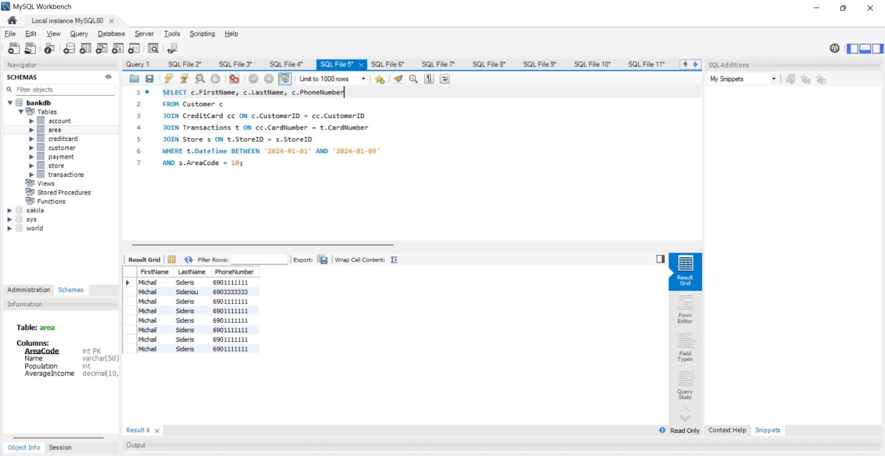
Show the name and phone number of customers who made a transaction from 1/1/2024 to 9/1/2024 at a store in the area code 10.

In this query I used JOIN conditions to connect related tables and show wanted results using WHERE

SELECT c.FirstName, c.LastName, c.PhoneNumber
FROM Customer c
JOIN CreditCard cc ON c.CustomerID = cc.CustomerID
JOIN Transactions t ON cc.CardNumber = t.CardNumber
JOIN Store s ON t.StoreID = s.StoreID
WHERE t.DateTime BETWEEN '2024-01-01' AND '2024-01-09'
AND s.AreaCode = 10;

Query 5
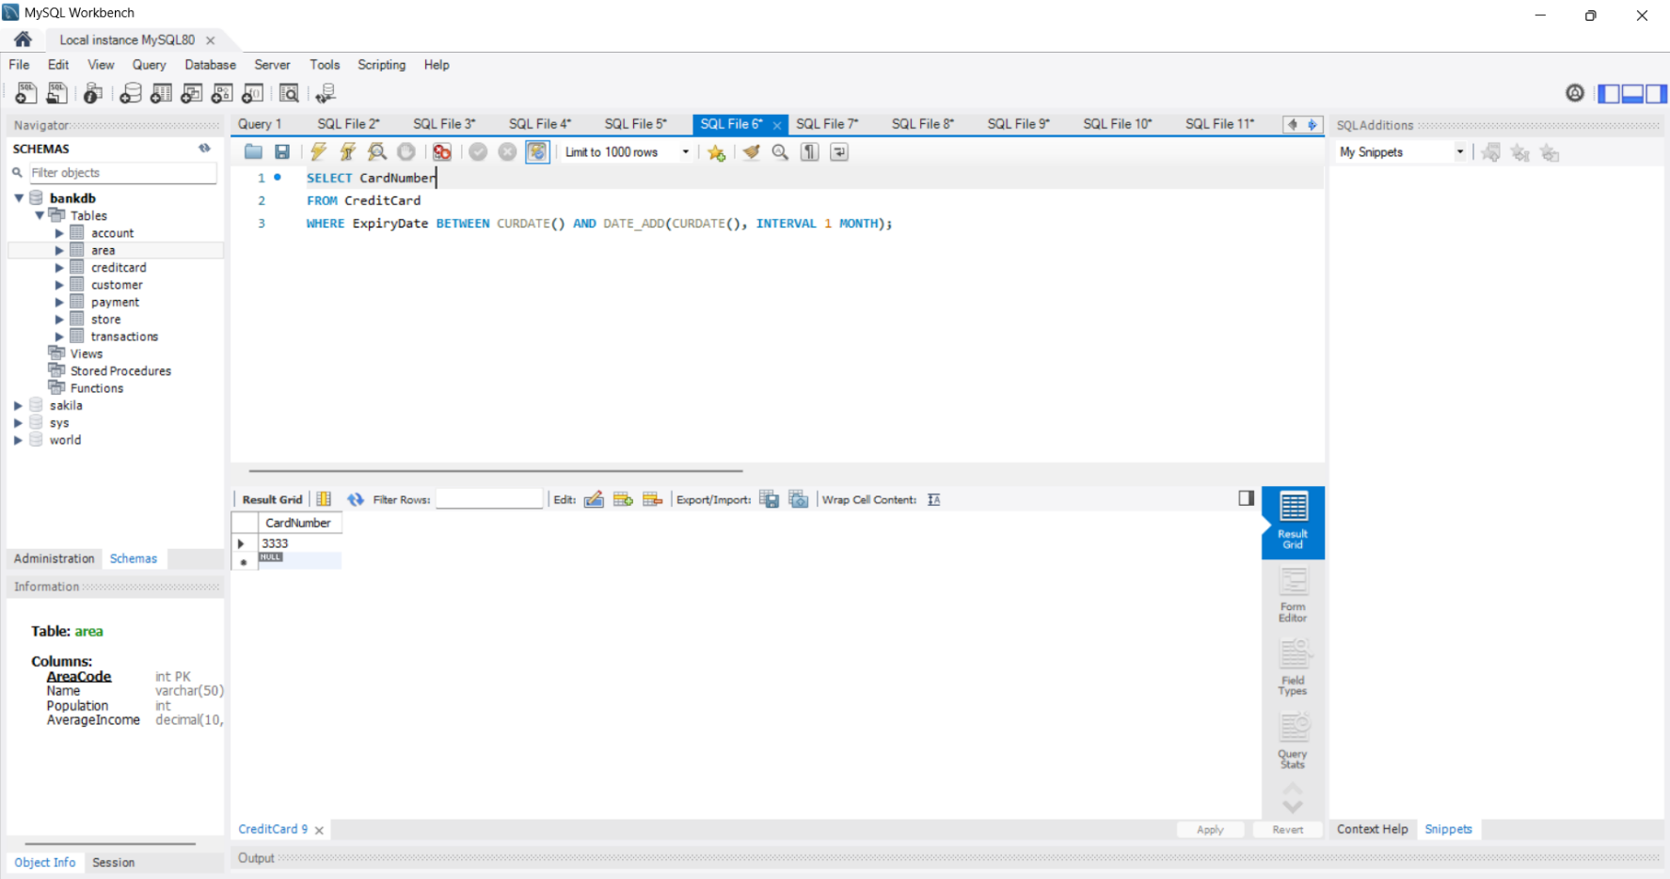
Find all the credit card numbers that expire in the period from today to one month from the current (today's) date.

In this query I used date functions to show which card expires at a specific date

SELECT CardNumber
FROM CreditCard
WHERE ExpiryDate BETWEEN CURDATE() AND DATE_ADD(CURDATE(), INTERVAL 1 MONTH);

Query 6
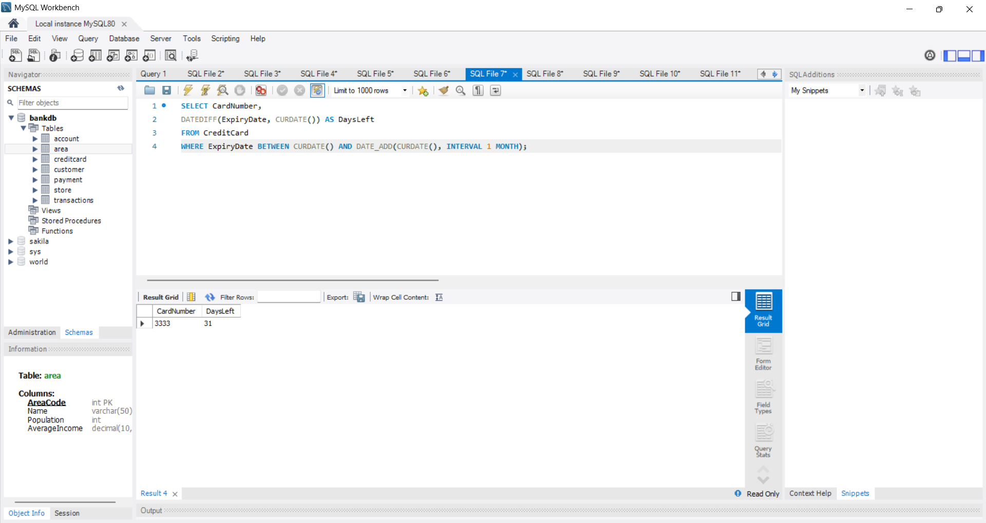
Find all the credit card numbers that expire in the period from today to one month from the current (today's) date and show how many days are left until expiration date.
In this query I used DATEDIFF to calculate the number of days left before the card expiry.
SELECT CardNumber,
DATEDIFF(ExpiryDate, CURDATE()) AS DaysLeft
FROM CreditCard
WHERE ExpiryDate BETWEEN CURDATE() AND DATE_ADD(CURDATE(), INTERVAL 1 MONTH);

Query 7
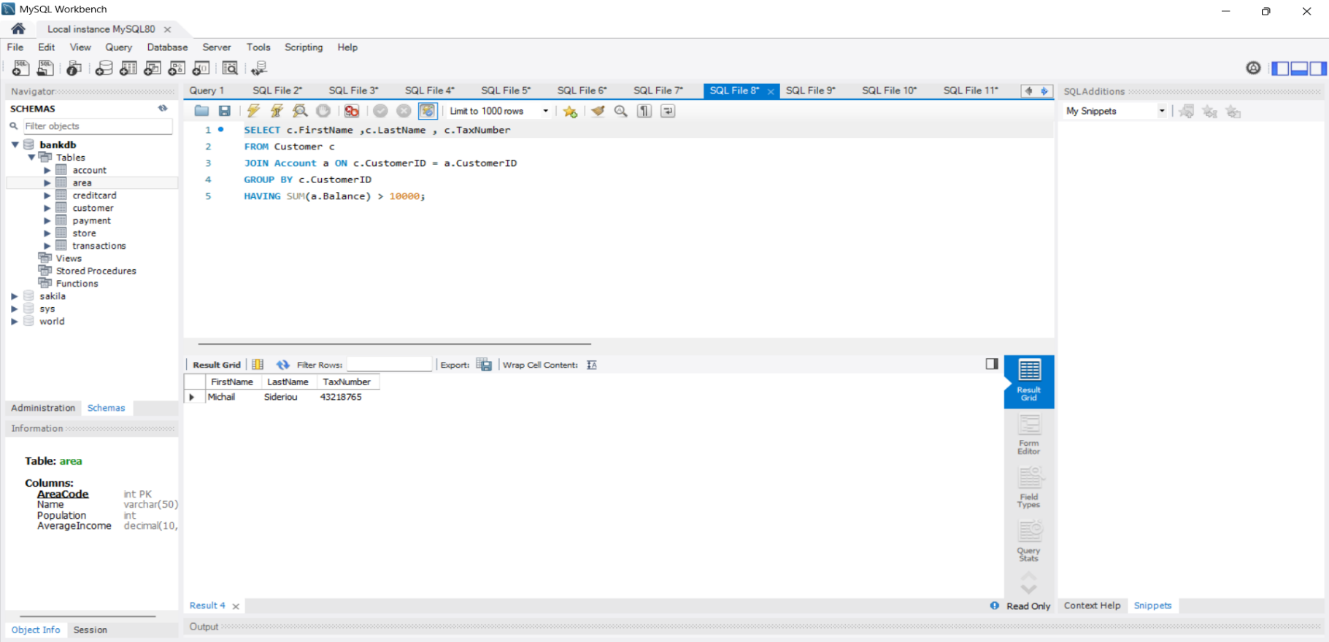
Find the name and tax number of all customers whose total balance in all their accounts is over 10,000 euros.
In this query I used GROUP BY and HAVING to filter customers based on the sum of the account balances.
SELECT c.FirstName ,c.LastName , c.TaxNumber
FROM Customer c
JOIN Account a ON c.CustomerID = a.CustomerID
GROUP BY c.CustomerID
HAVING SUM(a.Balance) > 10000;

Query 8
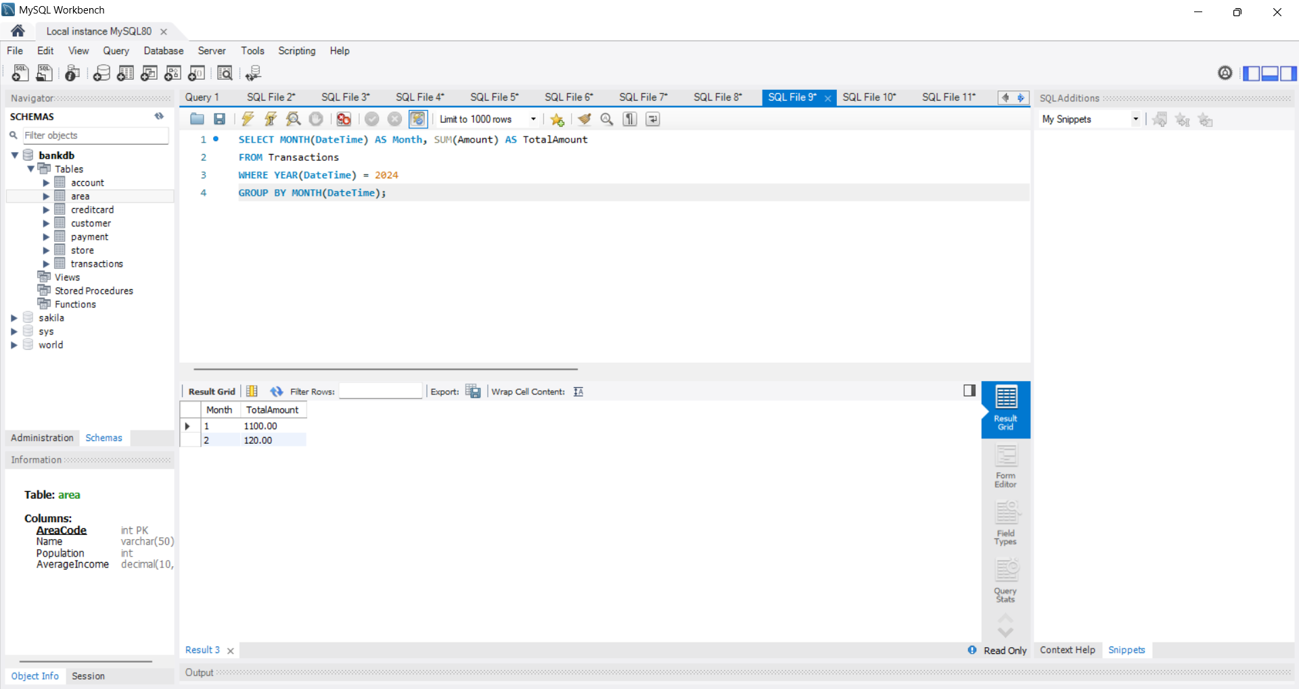
Show for each month of 2024, the sum of the amount of credit card transactions.

In this query using GROUP BY I summed transaction data per month

SELECT MONTH(DateTime) AS Month, SUM(Amount) AS TotalAmount
FROM Transactions
WHERE YEAR(DateTime) = 2024
GROUP BY MONTH(DateTime);

Query 9
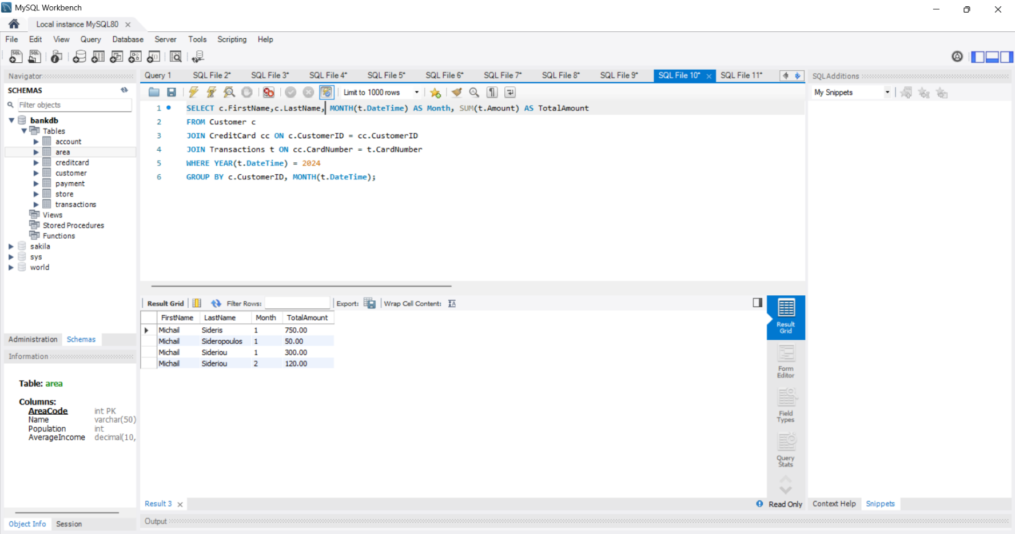
Show for each customer and each month of 2024, their name and the sum of the amount of their ​​transactions.
In this query I used GROUP BY to combine tables to calculate transaction totals per month and customer name

SELECT c.FirstName,c.LastName, MONTH(t.DateTime) AS Month, SUM(t.Amount) AS TotalAmount
FROM Customer c
JOIN CreditCard cc ON c.CustomerID = cc.CustomerID
JOIN Transactions t ON cc.CardNumber = t.CardNumber
WHERE YEAR(t.DateTime) = 2024
GROUP BY c.CustomerID, MONTH(t.DateTime);

Query 10
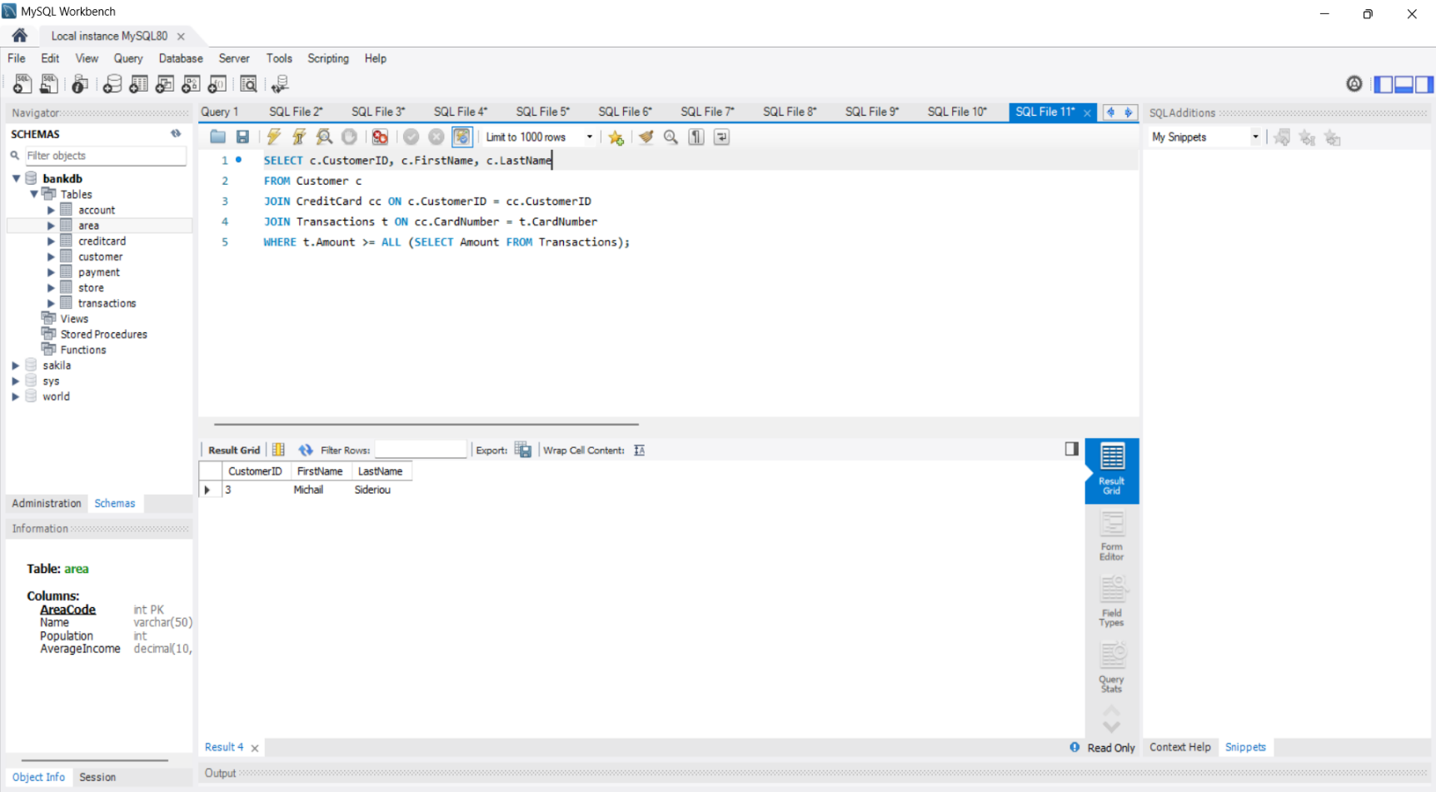
Using the keyword all: Find the code of the customer with the largest transaction.

In this query I used ALL to compare transaction amounts and find out which is the maximum value

SELECT c.CustomerID, c.FirstName, c.LastName
FROM Customer c
JOIN CreditCard cc ON c.CustomerID = cc.CustomerID
JOIN Transactions t ON cc.CardNumber = t.CardNumber
WHERE t.Amount >= ALL (SELECT Amount FROM Transactions);

BONUS
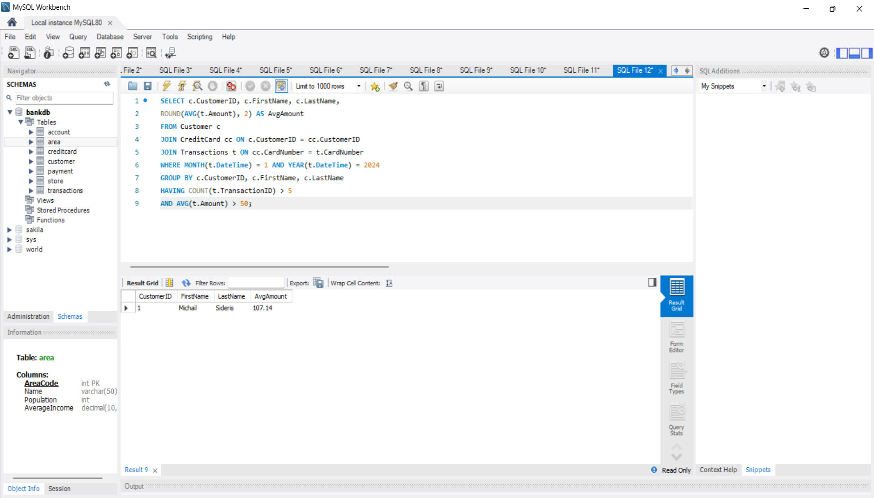
Show all customers who have made more than 5 purchases in January 2024 and the average purchase was over 50 euros

In this query I used COUNT and AVG that are aggregation functions with GROUP BY and HAVING to show the correct customers based on transaction number average amount of money spent

SELECT c.CustomerID, c.FirstName, c.LastName,
ROUND(AVG(t.Amount), 2) AS AvgAmount
FROM Customer c
JOIN CreditCard cc ON c.CustomerID = cc.CustomerID
JOIN Transactions t ON cc.CardNumber = t.CardNumber
WHERE MONTH(t.DateTime) = 1 AND YEAR(t.DateTime) = 2024
GROUP BY c.CustomerID, c.FirstName, c.LastName
HAVING COUNT(t.TransactionID) > 5
AND AVG(t.Amount) > 50;

